

**Parhad Keyim Idikut**

**5.2025**

**Inbound Tourism to Ireland:**

**Using Machine Learning to Predict Demand**

[**GitHub Link**](https://github.com/P-Idikut/Data-Analytics-for-Business)

**Table of Contents**

1. Introduction 2

2. Strategic Overview of the Business Problem: Irish Inbound Tourism 2

2.1 General Goal and Problem Definition 2

2.2 Scope 2

2.3 Document Processes 3

2.4 Ethical Considerations 3

2.5 Project Plan and Methodology 3

3. Business Understanding: Irish Inbound Tourism 4

4. Technologies Used 5

4.1. Libraries and Models 5

4.2 Model Selection and Appropriateness 5

5. Data Understanding 5

5.1 Data Sources/Acknowledgements 5

5.2 Descriptive Statistics, H0 and H1 hypotheses, and Findings 6

6. Data Preparation 8

6.1 Data Cleansing, Formatting and Exploratory Data Analysis (EDA) 8

6.2 Data Visualization and Identification of Relevant Variables and Features of Prediction 8

7. Forecasting and Evaluating Irish Inbound Tourism: Using ARIMA, SARIMA, and Theta Models 11

7.1 The UK: Total Tourist Expenditure, Per Tourist Per Night Expenditure, and Tourist Numbers 11

7.2 The US and Canada: Total Tourist Expenditure, Per Tourist Per Night Expenditure, and Tourist Numbers 13

**7.3 Model Evaluation and Comparison** 15

8. Challenges Encountered and Solutions 16

9. Findings, Recommendations, and Conclusion 16

References 17

# 

# 1. Introduction

Tourism is an industry which generally experiences sustained growth over time (Song, Qiu, & Park, 2019); however, it is vulnerable to fluctuations caused by local and global economic, political, and ecological challenges (Cheer and Lew, 2017).

Thus, this assignment hypothesises that Irish inbound tourism, as a part of international tourism, will continue to grow overall, but will experience temporary fluctuations.

This assignment report is the third part of a two-semester capstone project which aims to produce machine-learning models to predict inbound tourism demand in Ireland. The inbound tourism demand can be predicted in terms of overseas tourists, their average stay nights, and expenditure. The project aims to produce, evaluate and improve machine learning models’ accuracy and results.

# 2. Strategic Overview of the Business Problem: Irish Inbound Tourism

## ***2.1 General Goal and Problem Definition***

Predicting future tourism demand based on historical data can assist destination government authorities and tourism service companies in utilising their resources more efficiently, increasing their revenues, and minimising costs.

The main goal of this project is to predict inbound tourism demand in Ireland. The prediction could supplement the Irish tourism development strategies with a mission “To support a thriving tourism sector by managing Ireland’s natural, cultural and heritage assets, in harmony with local communities, while conserving these resources for use by future generations.” (Government of Ireland, 2024). In particular, the tourism demand prediction is relevant to the Irish government’s strategy of prioritising the economic value per visitor over the volume of tourists visiting (ibid., 2024; Irish Tourism Industry Confederation, 2024).

The accuracy of the tourism demand forecast is important for government authorities and all tourism service and product providers to effectively plan their future activities. Long-term tourism demand forecasting for forthcoming years helps a destination to plan infrastructure such as airports and hotels, etc, which takes a long time to develop (Gunter and Önder, 2015). Short-term forecasting for a few months is important for various tourism business providers to plan their staff requirements and inventory, and to upgrade the premises, etc., for upcoming busy seasons. Additionally, accurate forecasts are important for tourism destination decision-makers who are responsible for developing the local tourism market meanwhile minimising costs. Here, the tourism costs refer to the industry’s negative impacts on ecology (e.g. environmental pollution and biodiversity loss, etc.), and host communities (e.g. overcrowding, increasing local housing prices, etc.).

However, researchers (Song and Li, 2008) stated that there is no single outperformed model in terms of forecasting accuracy. For example, scholars (Gunter and Önder, 2015) used various models for predicting international tourism demand for Paris from the city’s five most important foreign source country markets. Their findings don’t show a clear indication of the best model across countries and forecast horizons.

## ***2.2 Scope***

This is a two-semester project with three CA reports. CA1 report focuses on project introduction and the strategic overview of the business, including general goal, problem definition, scope, ethical considerations and project plan.

The CA2 report focuses on data understanding and data preparation based on a historical inbound tourism dataset obtained from the Central Statistics Office of Ireland (Central Statistics Office, 2020a). The dataset covers 10 years of yearly data between 2009 – 2019.

Based on an additional inbound tourism dataset (1983 - 2018) obtained from the Central Statistics Office of Ireland (Central Statistics Office, 2020b), the CA3 report focuses on further data preparation on the new dataset, combining it with the old dataset, developing the prediction models, evaluating the models, discussing challenges encountered, and produce the final results and business recommendations.

## ***2.3 Document Processes***

The entire procedure of this project is documented in the form of project reports (CA1, CA2, and CA3), Jupyter's notebook, and the final poster presentation. Jupyter’s notebook is chosen to produce machine learning models. These documents are version-controlled in a GitHub repository.

## ***2.4 Ethical Considerations***

This project used two publicly available datasets published by the Central Statistics Office of Ireland (Central Statistics Office, 2020a and 2020b ). However, it is important to realise the limitations and consider all potential biases which might be caused by insufficient data previously mentioned. The tourism demand forecasting models are also affected by the missing data related to mode and price of transportation, tourism frequency, destination preference, age group, booking channels, accommodation preference (cost and type), and overall travel experiences in the destination country etc.

## ***2.5 Project Plan and Methodology***

This project is implemented by utilising the Cross-Industry Standard Process for Data Mining (CRISP-DM) methodology (Shearer, 2000) that consists of the following stages as shown in Figure 1.



Figure 1. Cross-Industry Standard Process for Data Mining (CRISP-DM) methodology

Source: Shearer, C., 2000. The CRISP-DM model: the new blueprint for data mining. *Journal of Data Warehousing*, *5*(4), pp.13-22.

As Figure 1 demonstrates, CRISP-DM is a cyclical process that encourages continuous improvement. Thus, any problems that arose from the stage of this project are resolved by looping back to an earlier stage, until a desirable result, i.e. the most appropriate tourism demand prediction model, is produced.

This project’s concert execution plan for each stage of the CRISP-DM model is shown in the following Table 1.



Table 1. Project timeline based on the CRISP-DM model

Sources: Adapted from Shearer (2000)

The first six phases (1, 2, 3, 4, 5, and 6) of this capstone project were implemented in the first semester and reported in CA1 and CA2.

The CA3 report on this semester, based on an updated project execution plan (see Table 1), focuses on further data preparation at phase 6, and the rest phases (7, 8, and 9) and is described in detail below, along with other sections.

# 3. Business Understanding: Irish Inbound Tourism

As an important phase of the CRISP-DM model, the Business Understanding phase focuses on understanding the general business objectives, assessing the situation, and determining analytical goals.

In general, tourism is one of the industries that has shown sustained growth (Song, Qiu and Park, 2019). However, tourism is vulnerable to various fluctuations that can be caused by local and global economic, political and natural (ecological) challenges. In this context, tourism demand prediction can be a difficult task. Forecasting of tourism demand has been mainly focused on international tourist flows, e.g., inbound tourism, thanks to the relatively easy availability of statistical data compared to domestic tourism (ibid., 2019). International tourism demand is mostly measured with variables like tourist arrivals, tourism expenditure, or length of stay (Song and Li, 2008). Tourist arrivals are further categorised into holiday tourist arrivals, business tourist arrivals, and tourists’ arrivals for visiting friends and relatives (VFR) purposes (ibid., 2008). Researchers (Song and Li, 2008) stated that there is no single outperformed model in terms of forecasting accuracy. For example, scholars (Gunter and Önder, 2015) used various models for predicting international tourism demand for Paris from the city’s five most important foreign source country markets. Their findings don’t show a clear indication of the best model across countries and forecast horizons.

In the Irish context, tourism is the country’s largest indigenous industry and biggest regional employer (Irish Tourism Industry Confederation, 2024). For developing the tourism industry, the Irish government aims to implement a sustainable development strategy, i.e., equally consider the environmental, economic, and social pillars of sustainability. More specifically, the Irish tourism policy framework is based on the following guiding principles (Government of Ireland, 2024, p.21):

* Protect and enhance Ireland’s cultural heritage, natural assets and environmental quality.
* Ensure that tourism contributes to meeting national and international policy commitments on climate change.
* Support balanced economic development and employment throughout the country.
* Prioritize the economic value per visitor over the volume of tourists visiting.
* Minimize any negative impacts of tourism on host communities and maximize the social benefits of tourism.
* Encourage innovation within the tourism sector to ensure improved visitor satisfaction.
* Ensure Ireland is recognized as an authentic, sustainable destination.

Among these guiding principles, “Prioritize the economic value per visitor over the volume of tourists visiting” is especially relevant to the aims/analytical goals of this capstone project. As previously mentioned, this project aims to produce machine-learning models to predict inbound tourism demand in Ireland, i.e. the prediction of the number of overseas tourists, their average stay nights, and expenditure. Increasing per-tourist expenditure instead of developing mass tourism could be a way to maximise tourism’s positive economic impact (e.g., increasing tax revenue, creating local employment, etc.) while protecting the destination environment e.g., minimising the ecological and social negative impacts).

# 4. Technologies Used

This part describes the chosen Python libraries and machine-learning models that are used in this report.

## ***4.1. Libraries and Models***

This project utilised tools and technologies, including essential Python libraries such as Pandas, NumPy, Matplotlib, Seaborn, Scikit-learn, Sklearn, Sktime, and so on. It also used stat tools like the Shapiro-Wilk Test, QQ-plot, ANOVA, Box plot, Adfuller, ACF, PACF, models such as ARIMA, SARIMAX, and Theta Forecaster.

## ***4.2 Model Selection and Appropriateness***

Appropriate machine learning algorithms are needed to develop the Irish inbound tourism demand forecasting models. This assignment focused on time series analysis because forecasting tourism demand is a prediction problem. For tourism forecasting, the most frequently used models are time-series models that predict the future of the series based on historical data (Gunter and Önder, 2015).

In time-series models, Autoregressive Integrated Moving Averages (ARIMA) and Seasonal Autoregressive Integrated Moving Averages (SARIMA) techniques are commonly used. SARIMA is a time series forecasting model that uses the past movements of variables to predict their future values (Arunraj et al., 2016). By including additional seasonal terms in the ARIMA models, the SARIAM model or Seasonal ARIMA model, can model a wide range of seasonal data.

The model is written as SARIMA(p, d, q)(P, D, Q)m. It is formed by including additional seasonal terms (P, D, Q) in the ARIMA model’s non-seasonal components (p, d, q). p, d, and q, respectively, refer to the number of autoregressive, the degree of differencing, and the number of moving average terms. m refers to the number of periods in each season.

Additionally, the Theta Forecaster model is used to forecast Irish inbound tourism. The Theta model is a forecasting method that involves fitting two lines, forecasting the lines using a Simple Exponential Smoother, and then combining the forecasts from the two lines to produce the final forecast (Perktold et al., 2024).

# 5. Data Understanding

## 

## ***5.1 Data Sources/Acknowledgements***

This project used the tourism datasets obtained from the Central Statistics Office of Ireland (Central Statistics Office, 2020a and 2020b). The datasets cover 10 years between 2009 – 2019 (Central Statistics Office, 2020a) and 25 years between 1983 – 2008 (Central Statistics Office, 2020b). The datasets are open source for non-commercial use.

## ***5.2 Descriptive Statistics,*** ***H0 and H1 hypotheses, and Findings***

This section includes descriptive analysis (Histogram, Shapiro-Wilk Test, and QQ-plot), inferential statistics (one-way ANOVA, two-way ANOVA), H0 and H1 hypotheses, their relevant visualizations, and findings. A histogram is used as a visual tool for checking the distribution of data normality.

While the null hypothesis (H0) states the variable is normally distributed, the alternative hypothesis (H1) states the variable is not normally distributed. The Shapiro-Wilk test checks if a continuous variable follows a normal distribution. QQ-plot compares the observed distribution with the theoretically expected distribution. It tests the null hypothesis, i.e., data are normally distributed.

Descriptive statistics describe features of a data set by summarising the data samples. Summary statistics reflect central tendency (mean, median and mode), and measures of dispersion or variability (minimum and maximum values, range, variance, standard deviation, and IQR) (Weiss, 2016). The summary statistics for the whole data frame (1983 – 2019) will be described in the forecast model-building section of this report. The whole data frame is created after conducting data preparation on the second data frame (1983 – 2008) and combining it with the first data frame (2009 – 2019).

The first data set (2009 – 2019) of this assignment included 8 features and 297 observations. The are no duplicate rows. There are 5 columns represented by the ‘object’ data type, 2 columns by the ‘int64’ data type, and 1 column by the ‘float64’ data type.

There are 24 missing values in the columns called “VALUE”. The missing values consist of 8.08 % of the overall dataset, and they will be dropped in the Data Preparation phase of this project.

As Figure 2 below demonstrates, only one column called “VALUE” has numerical values. Values in the column “C02173V02619” are the abbreviation of the column “Areas of Residence”. Columns “TLIST(A1)” and “Year” have the same values: year. Values in column “STATISTIC” correspond to the values in column “Statistic Label”. Values in column “UNIT” are the measuring units of the values in the column “VALUE”.

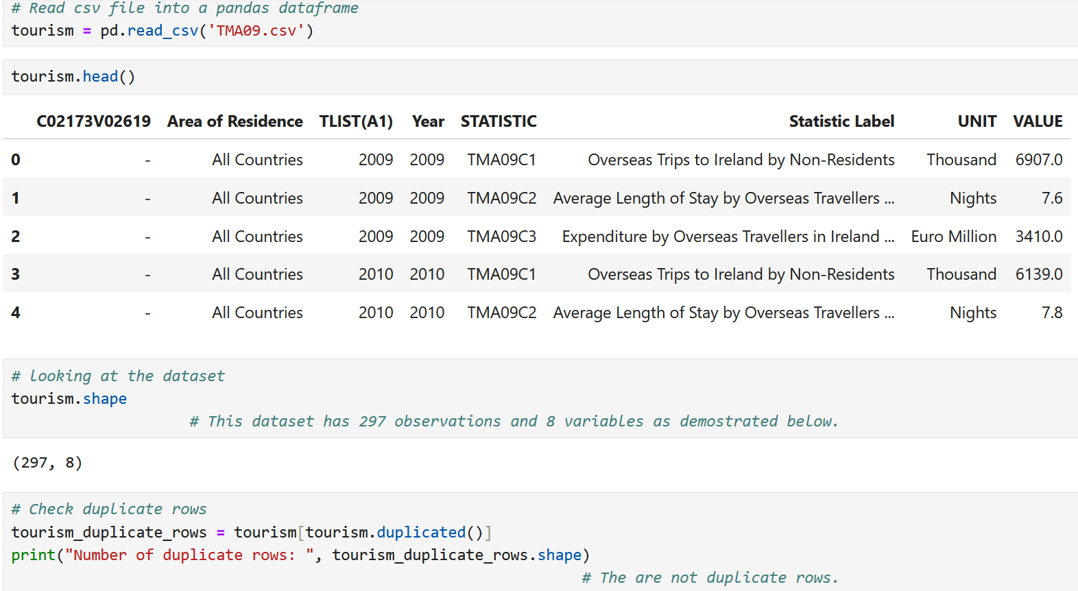

Figure 2. Irish inbound tourism dataset (2009 – 2019)

Thus, columns including “C02173V02619”, “TLIST(A1)”, “Statistic Label”, and “UNIT” will be removed/dropped in the Data Preparation phase.

Descriptive statistics (e.g., Histogram, Shapiro-Wilk Test, and QQ-plot) of ‘VALUE’ show that it does not appear to be normally distributed (see Figure 3).

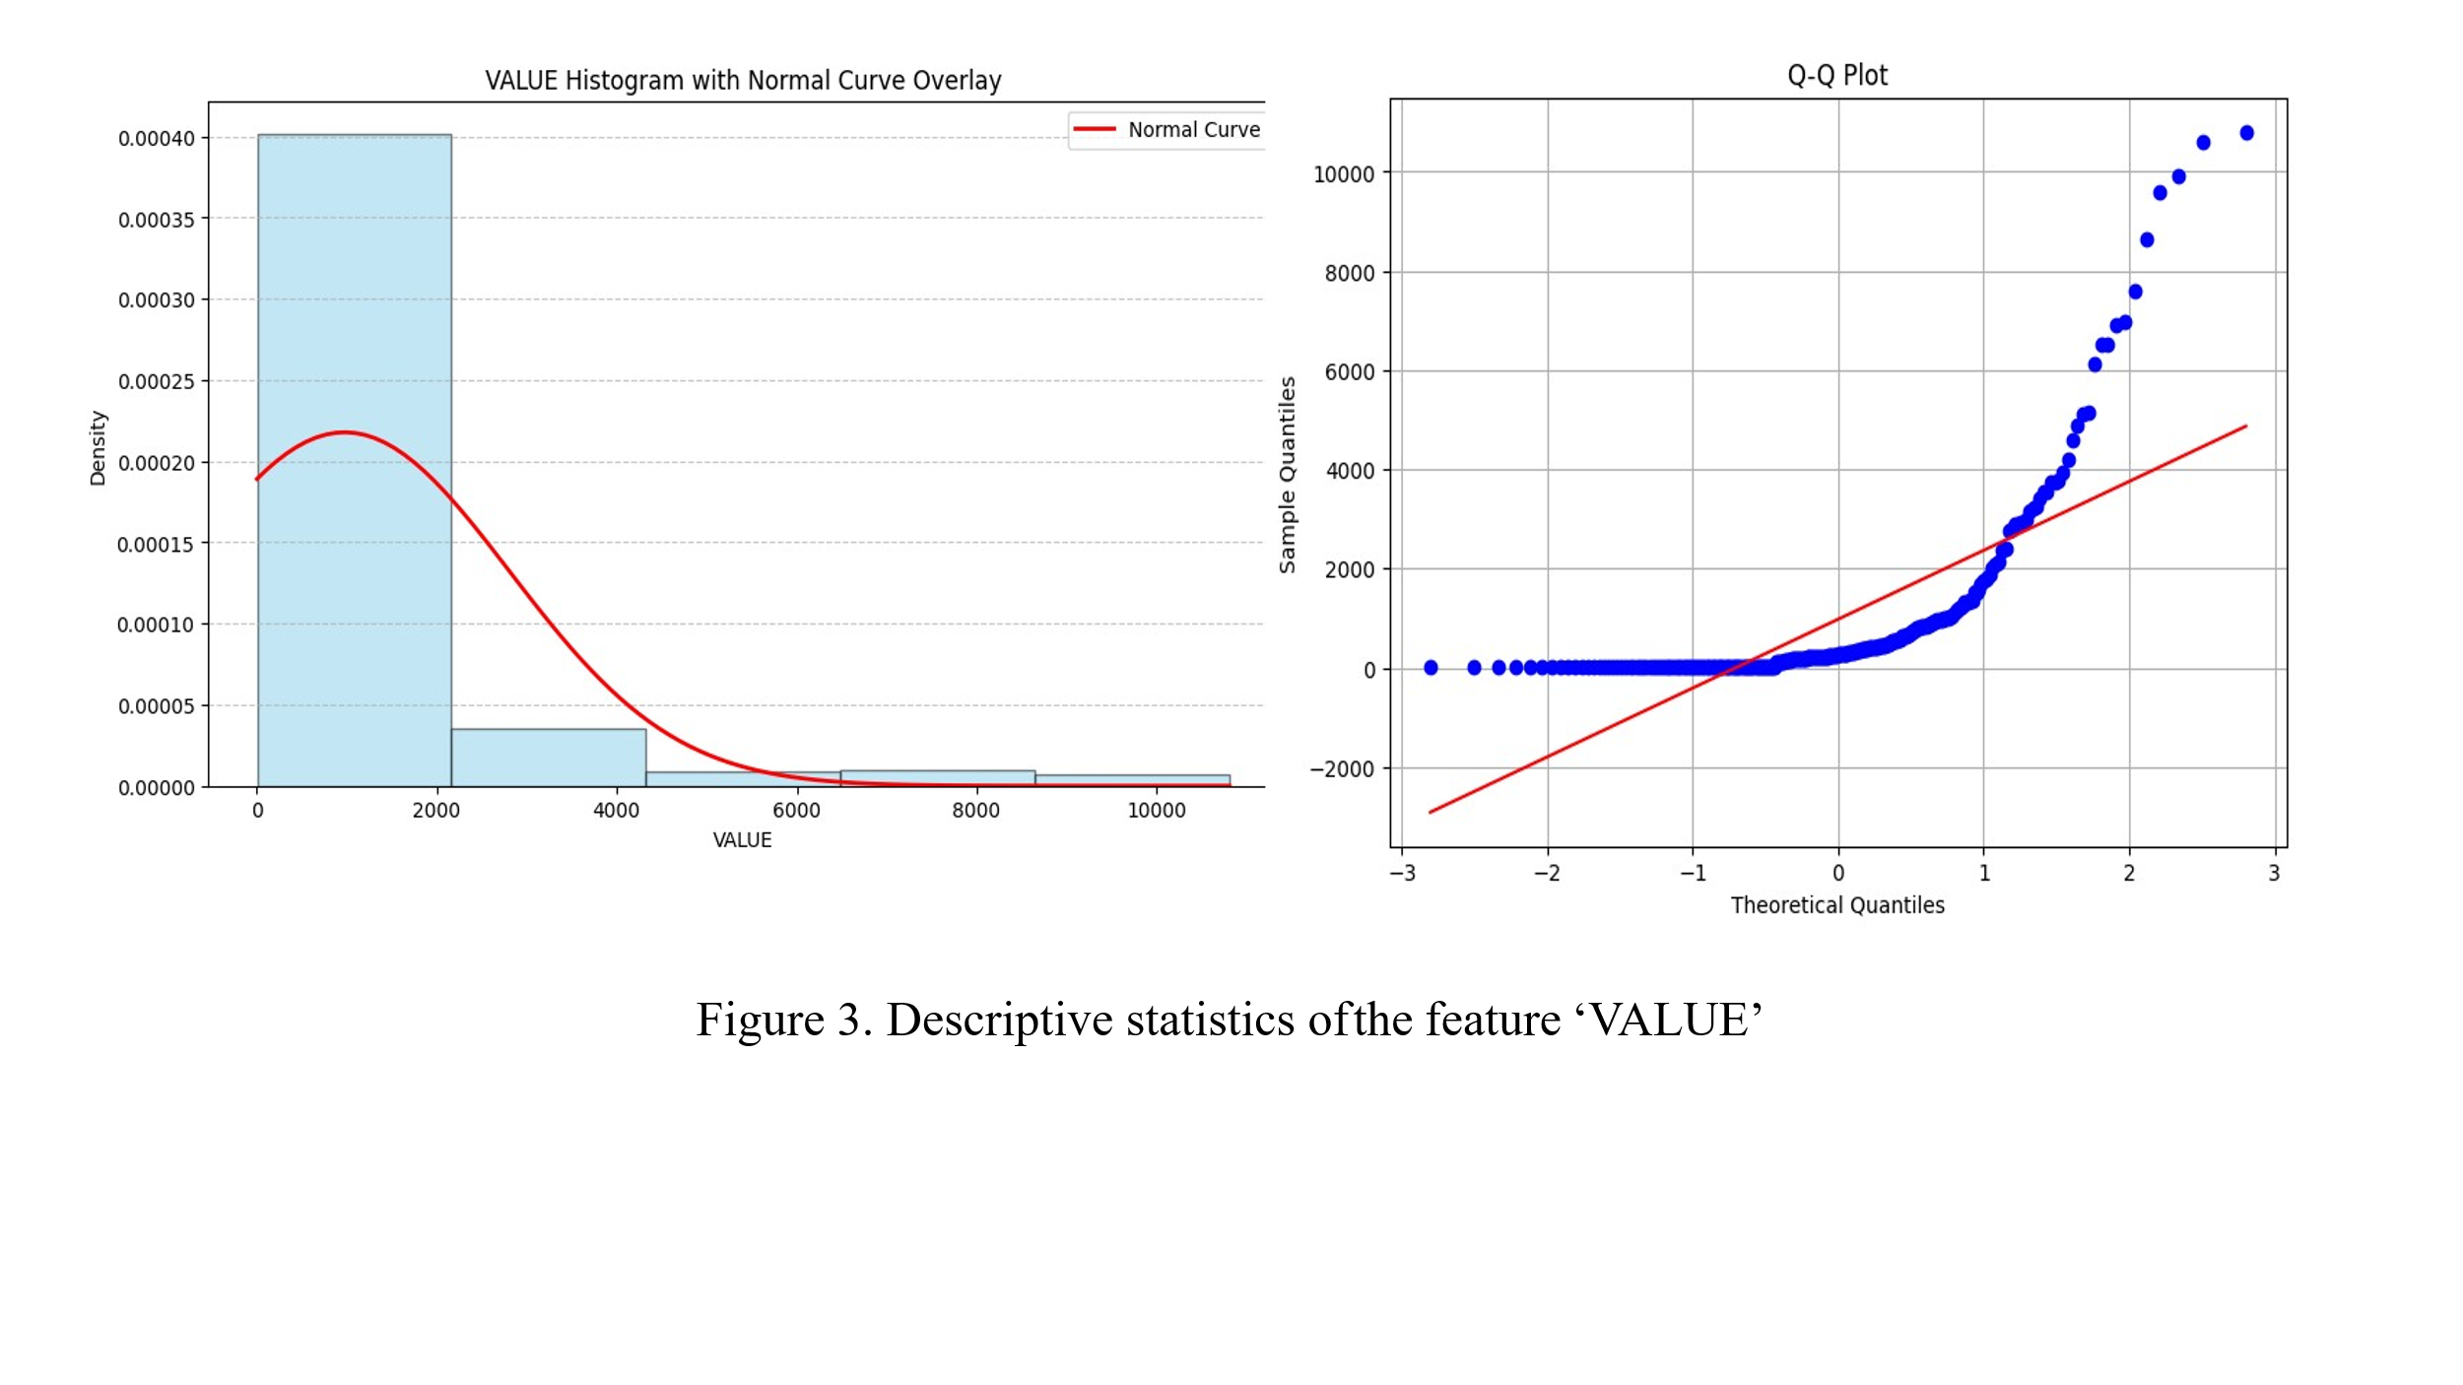This means that it needs to perform a transformation, e.g., differencing, to normalise the time series data to deal with non-stationarity. Since stationary data could improve the prediction accuracy of time-series analysis.

Inferential Statistics, e.g., a boxplot of “Residence” indicates that the most “VALUE” of inbound tourists to Ireland come from Great Britain, the United States and Canada (combined), Germany and France (see Figure 4).

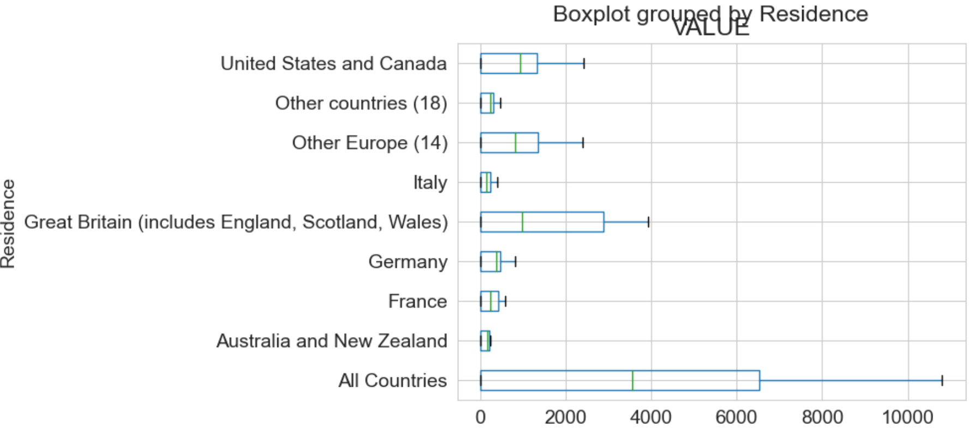

Figure 4. Boxplot of the nationality of the inbound tourists to Ireland.

Thus, those countries will be the focus of further data analysis and tourism demand forecasting in the later phases of this project.

The two-way ANOVA analysis shown in Figure 5 demonstrates that the p values are 0 and significantly smaller than 0.05. This indicates that there are significant differences in VALUE by Residence(countries) and tourists to Ireland (TouristsNumber, AverageStayNights, and TouristsExpenditure).

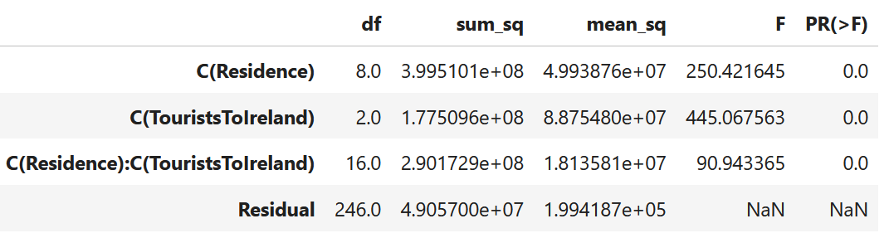

Figure 5. Two-way ANOVA

# 6. Data Preparation

Data preparation allows us to understand the relationships among the features and reveals interesting insights within the data. Data preparation ensures the dataset used in the machine learning applications produces reliable results and enables more informed decision-making by business executives and operational workers.

## ***6.1 Data Cleansing, Formatting and Exploratory Data Analysis (EDA)***

The missing values are removed from the dataset, as they only account for 8.08 % of the overall data.

As previously mentioned, this project aims to forecast inbound tourism demand in Ireland. In this context, time (“Year”) and value (“VALUE”), “Area of Residence”, and “STATISTIC” are the most important features. So, the unnecessary columns/features, which were explained before, are removed from the dataset to reduce noise.

Columns and value names of “TouristsToIreland” are renamed. The data frame is pivoted, and a new column called “ExpenditurePerTouristPerNight” is created for the convenience of further analysis (see Figure 6).

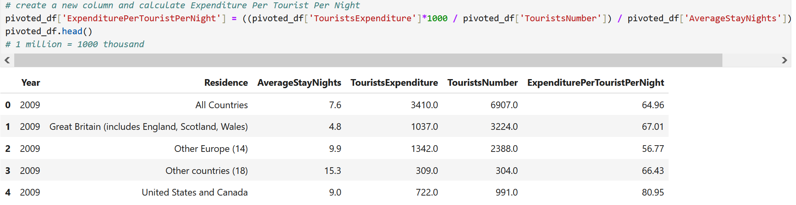

Figure 6. Cleaned dataset of the Irish inbound tourism (2009 – 2019)

The feature “ExpenditurePerTouristPerNight” is one of the important features that is used for Irish inbound prediction, as it allows a comparison of Irish inbound per-tourist per-night expenditure generated by tourists from different countries. Predicting and analysing the new feature helps address the Irish government’s tourism development policy of “Prioritising the economic value per visitor over the volume of tourists visiting” (Government of Ireland, 2024).

## ***6.2 Data Visualization and Identification of Relevant Variables and Features*** ***of Prediction***

The data frame is grouped by “residence”(countries), aggregated, and calculated mean values of “AverageStayNights”, “TouristsExpenditure”, “TouristsNumber”, “ExpenditurePerTouristPerNight”, sorted by the “TouristsExpenditure”, dropped “All Countries” from “residence”, and piloted (see Figure 7).

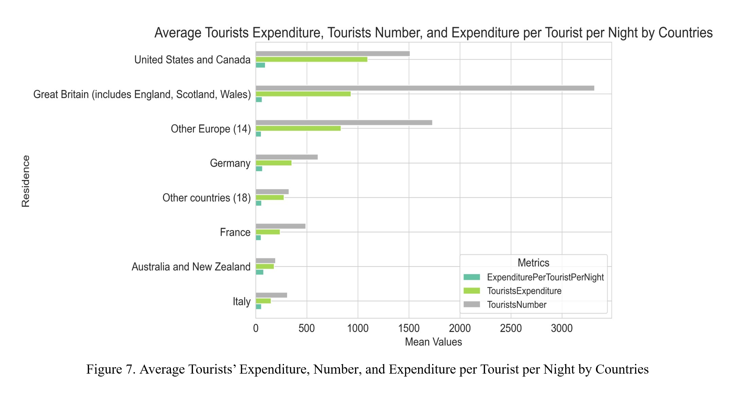

Figure 7 shows that the United States, Canada (combined), the UK, Germany, and France are the most important individual countries that contribute to Irish inbound tourism. The United States and Canadian tourists’ Expenditures are higher than the UK’s, even though the US and Canadian Tourists’ Numbers are less than half of the UK’s.

Per tourist per night expenditure, tourist expenditure by year and residence, tourist number by year and residence, and average stay nights by year and residence are plotted to examine the current business trends of Irish inbound tourism in more detail (see Figure 8).

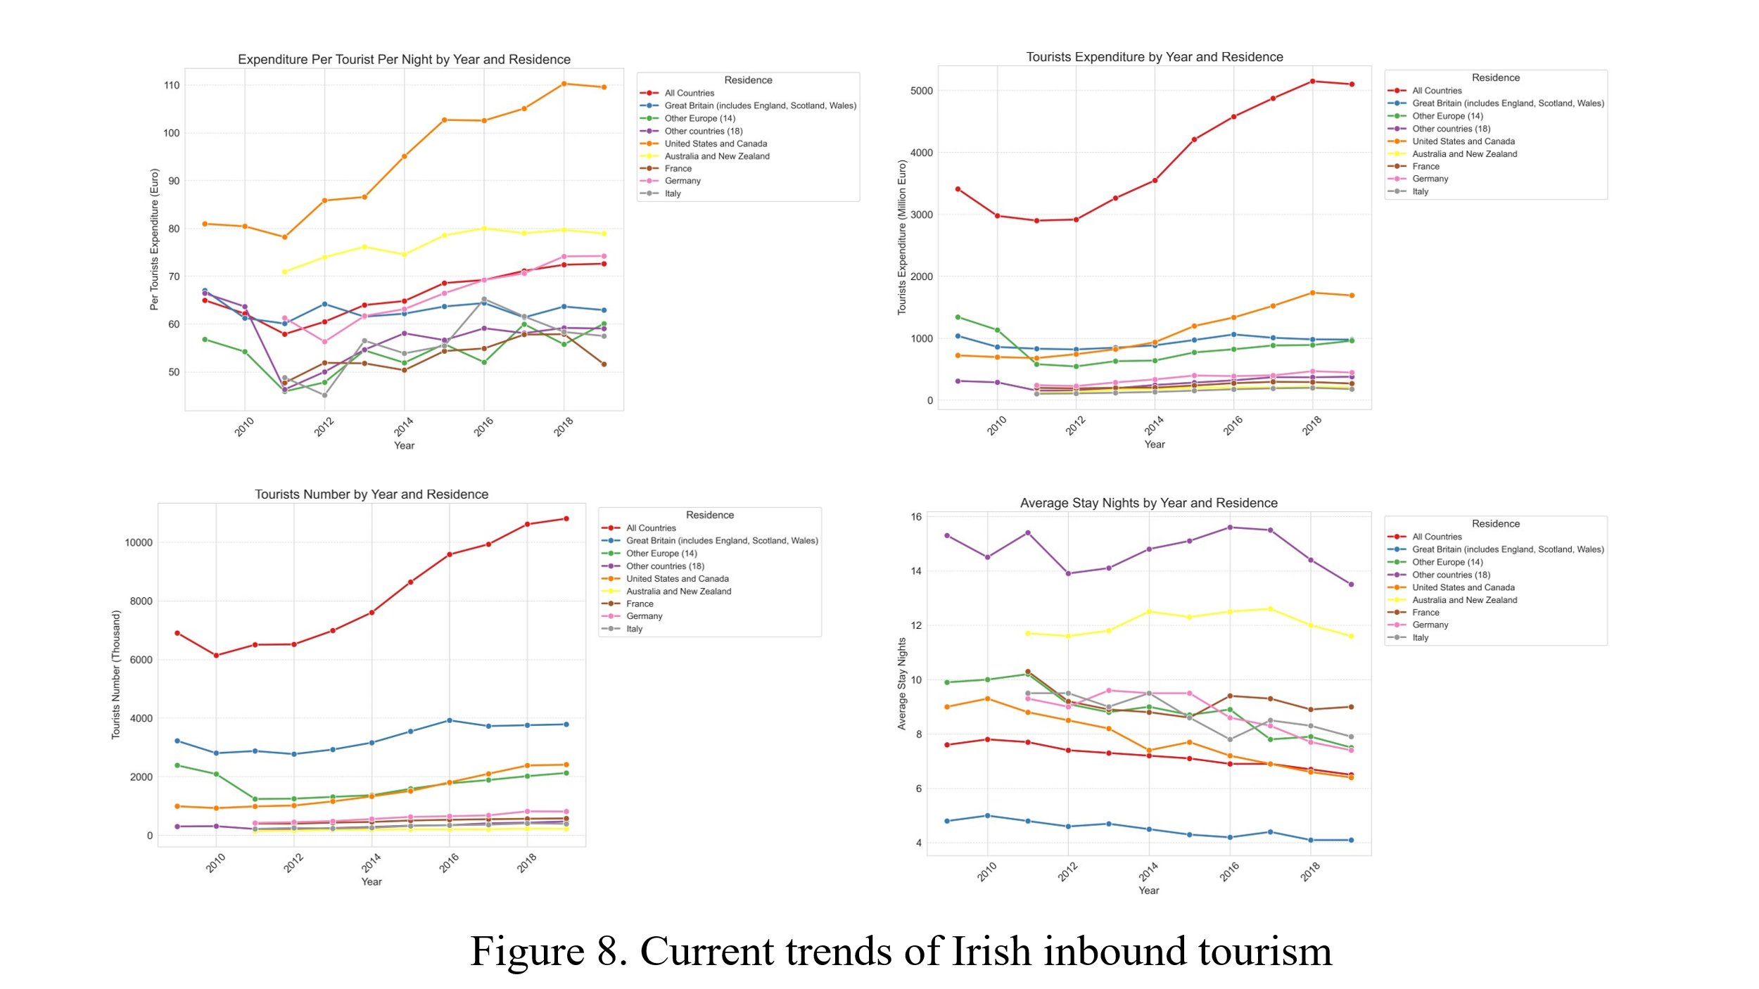

Figure 8 shows that, between 2010 and 2019, the per tourist per night expenditure in Ireland generally increased. Tourists from the United States and Canada consistently recorded the highest per-night spending, reaching €110 in 2019. Other regions, including Australia and New Zealand, Germany, France, and Other European countries, also showed gradual increases. In contrast, tourists from Great Britain and Italy show fluctuations in their per-night expenditure over the period, without a consistent upward pattern, and their spending remained lower than that of North American visitors.

Total tourist expenditure in Ireland rose over the decade, with the United States, Canada, and Great Britain making significant contributions, particularly after a small decline around 2011–2012. The increase in total expenditure might be partly driven by the rise in per-night spending by tourists from North America.

The number of tourists visiting Ireland increased steadily from 2010 to 2019, although there was a dip around 2011–2012. By individual country, Great Britain remained the dominant source, followed by the United States and Canada.

The average length of stay by tourists in Ireland showed a slight declining trend over the period. Tourists from Australia and New Zealand consistently stayed the longest, averaging around 12 nights, whereas visitors from Great Britain had the shortest stays, decreasing from 5 to 4 nights.

In summary, these findings are like the results of the previously conducted inferential statistics, e.g., the boxplot of “Residence” (see Figure 4) that the United States, Canada and Great Britain are the main contributors to Irish inbound tourism.

Additionally, TouristsExpenditurePortion (%) and TouristsNumberPortion(%) in total tourist expenditure and numbers by countries over time are calculated and plotted (see Figure 9).

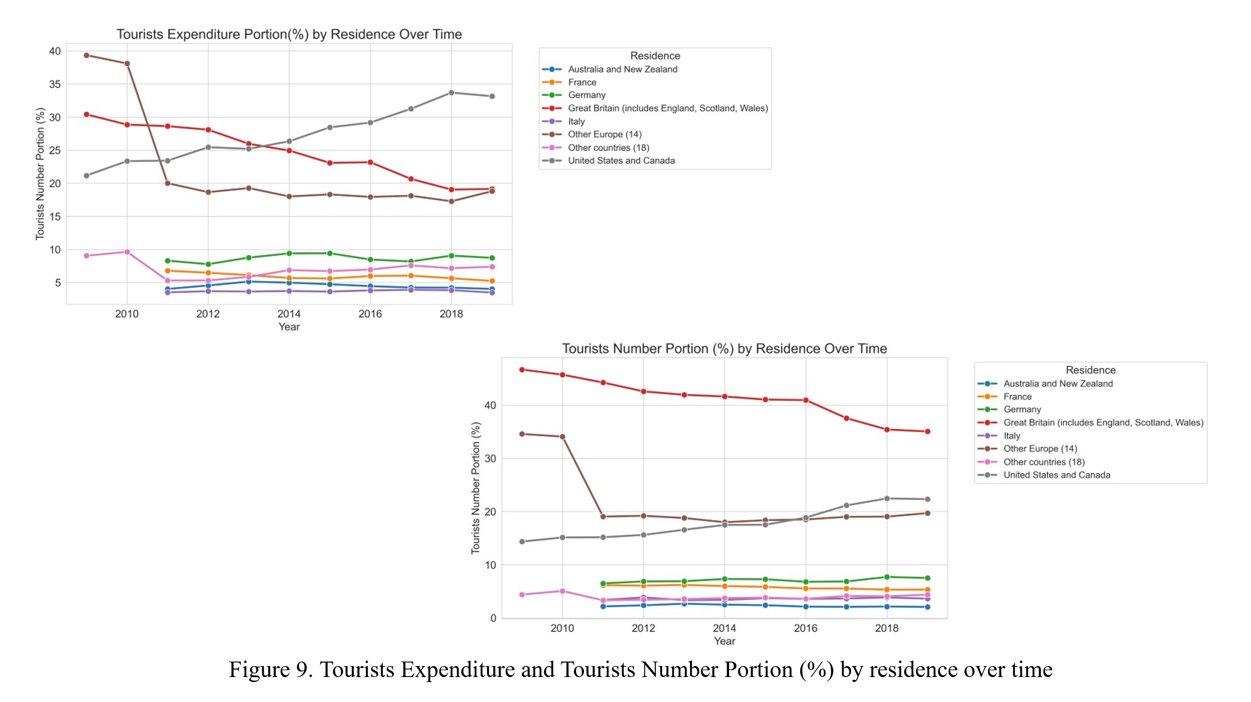

According to Figure 9, between 2010 and 2019, the share of tourist expenditure from the United States and Canada steadily increased from around 20% to 35%, becoming a main contributor by the end of the period. In contrast, Great Britain shows a clear decline in its expenditure portion, which decreased from around 40% to 20%. Germany, France, Italy, Australia and New Zealand, and Other European countries maintained relatively small and stable expenditure shares.

Tourist numbers portions followed similar trends. Great Britain started with the largest share but declined steadily over time. Meanwhile, the proportion of tourists from the United States and Canada grew from around 15% to 22%. Other countries remained relatively stable with minor fluctuations.

Overall, the data suggests, the United States, Canada and Great Britain are the main contributors to Irish inbound tourism. However, there is a shift from British tourism dominance towards North American tourists in both spending and visitor numbers. These findings again suggest that Irish inbound tourism forecasting should be focused on Great Britain, the US and Canada.

Using the same data preparation methods, the additional inbound tourism dataset (1983-2008) of Ireland is cleaned and combined with the other inbound tourism dataset (2009-2019). This new dataset is cleaned and pivoted to prepare data for conducting the time series analysis (see Figure 10).

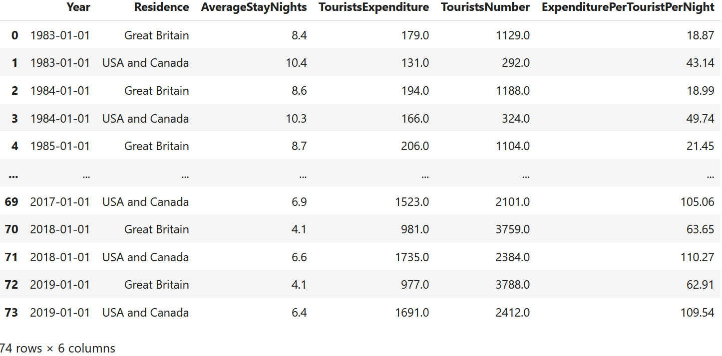

Figure 10. Cleaned dataset of the Irish inbound tourism (1983 – 2019)

# 7. Forecasting and Evaluating Irish Inbound Tourism: Using ARIMA, SARIMA, and Theta Models

The time series analyses started with a check for stationarity by using the Augmented Dickey-Fuller (ADF) test. It tests the null hypothesis that a time series has a unit root (i.e., it is non-stationary). Rejecting the null hypothesis means considering the time series as stationary. If it is not stationary, differencing is carried out until reaching stationarity. Differencing means subtracting the previous value from the current value to stabilise the mean.

Time-series model-building parameters such as p,d, and q can be estimated by ACF and PACF plotting of the stationary data.

## ***7.1 The UK:*** ***Total Tourist Expenditure, Per Tourist Per Night Expenditure, and Tourist Numbers***

The ACF and PACF plots for forecasting the UK total tourist expenditure, per tourist per night expenditure, and tourist numbers can be seen in the following Figure 11.

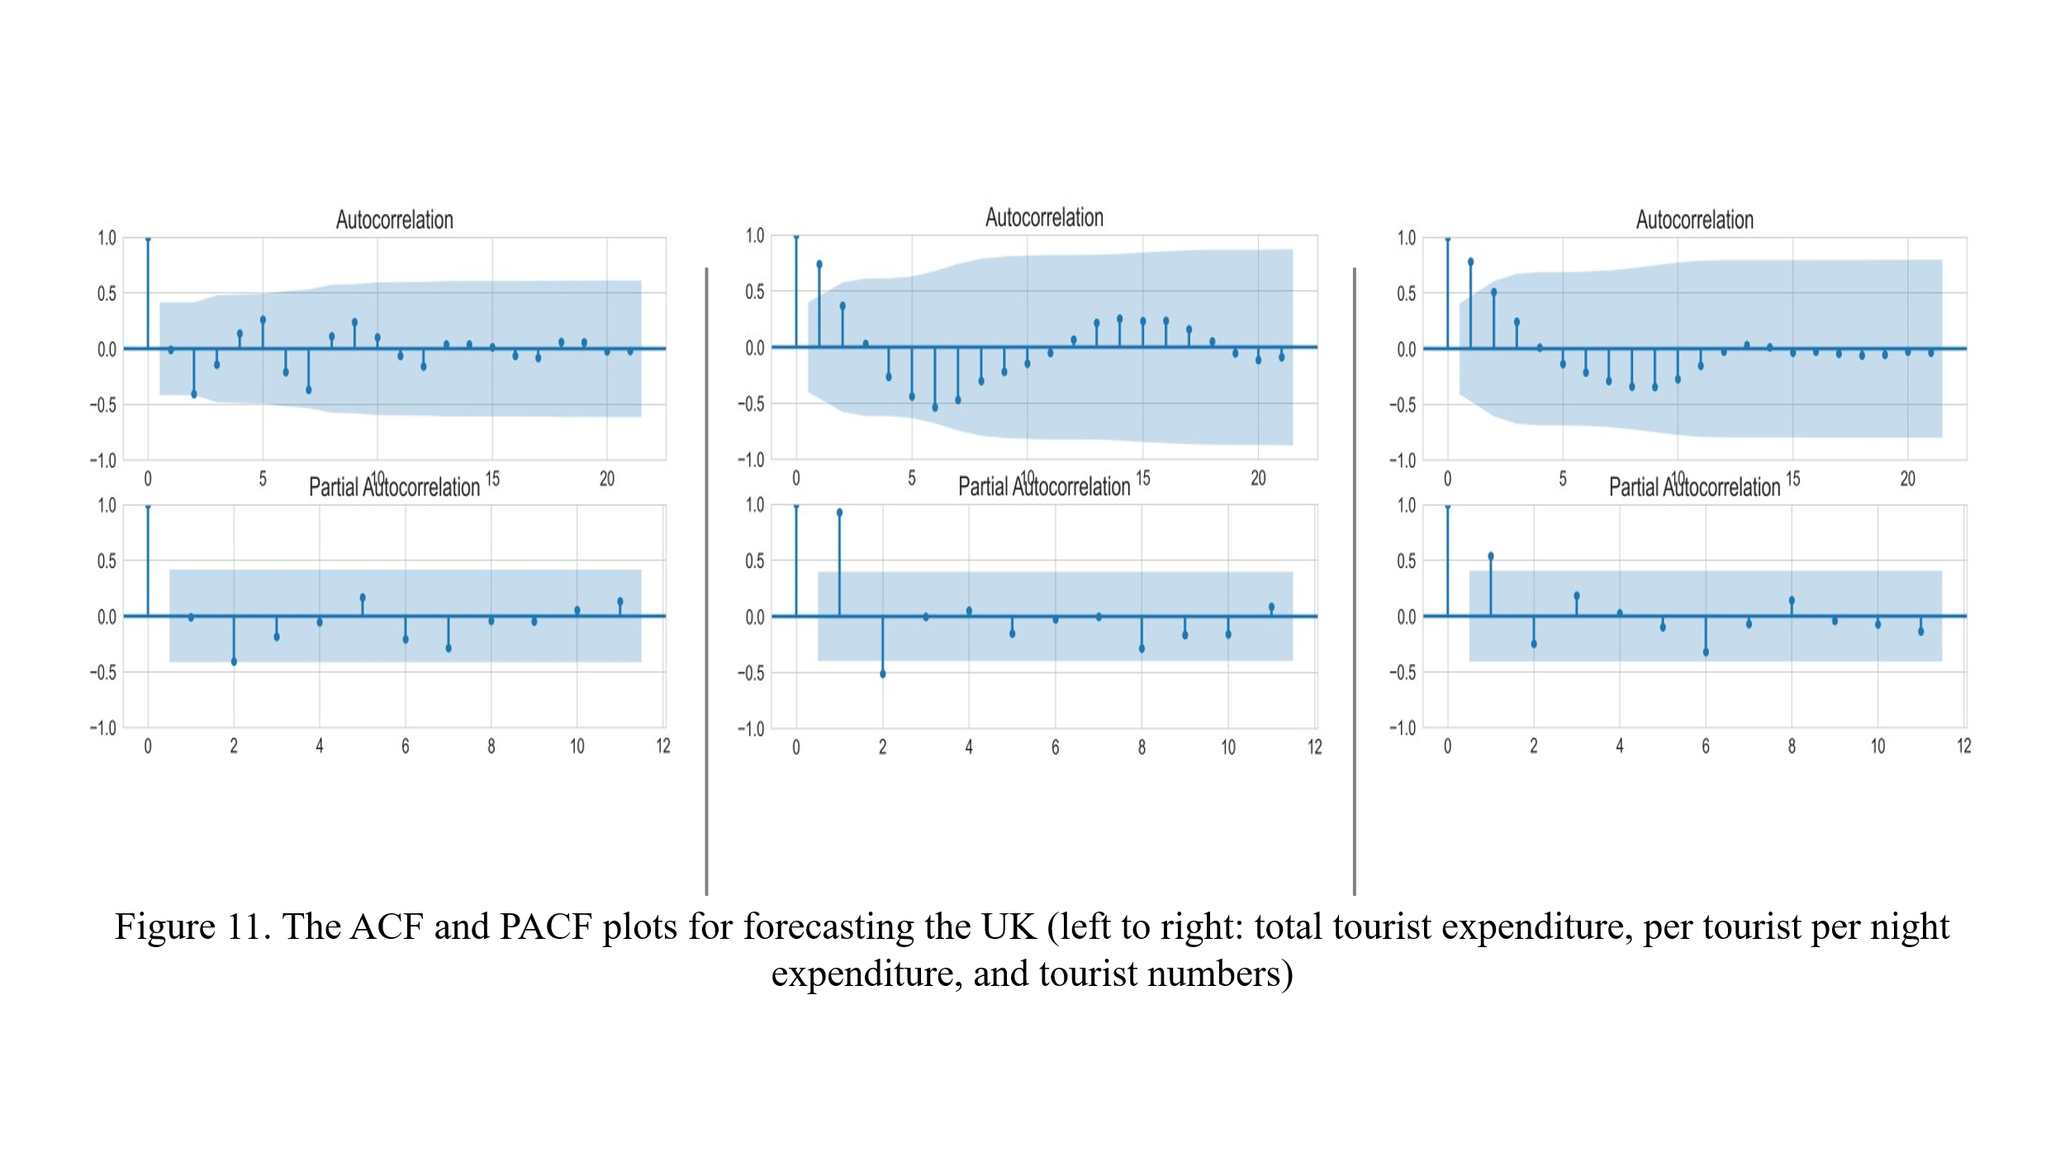

Based on the estimated p,d, and q values according to the ACF and PCA, the ARIMA, SARIMA, and Theta Models are built to estimate the Irish inbound tourism that comes from the UK. Forecasting for the UK total tourist expenditure can be seen in the following plots (Figure 12).

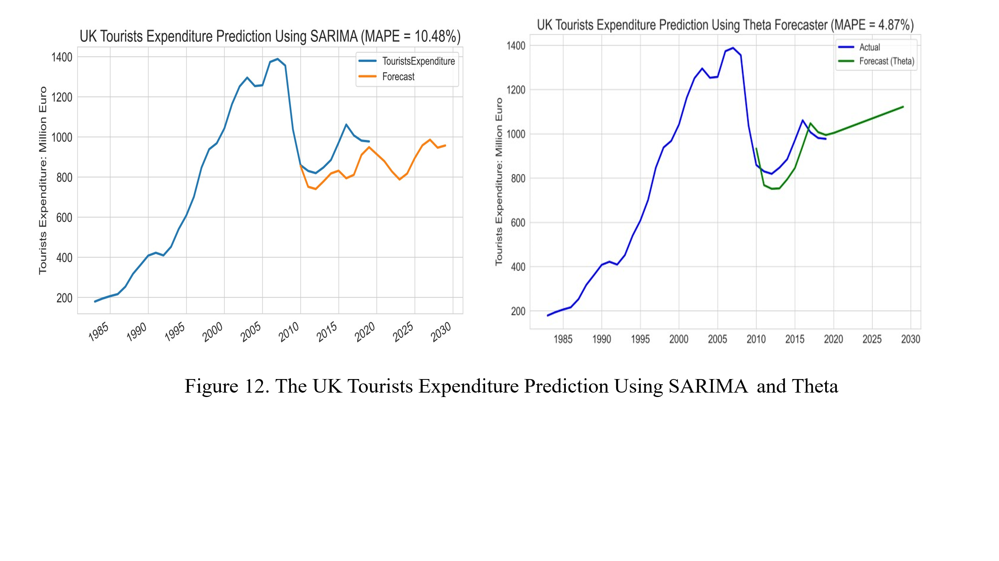

Grid search over AIC value is performed to find out the best p,d, and q for optimizing the model accuracy. The model built based on this method got a very low accuracy with an MAPE value of 257.96%.

Forecasting for the UK per tourist per night tourists’ expenditure can be seen in the following plots (Figure 13).

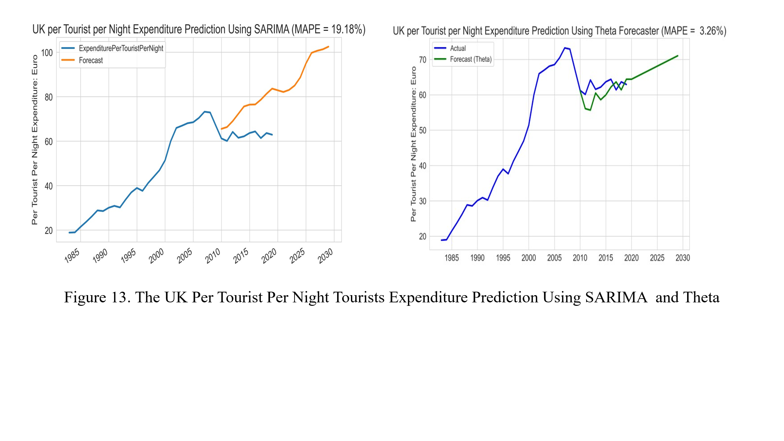

Forecasting for the UK tourist numbers can be seen in the following plots (Figure 14).

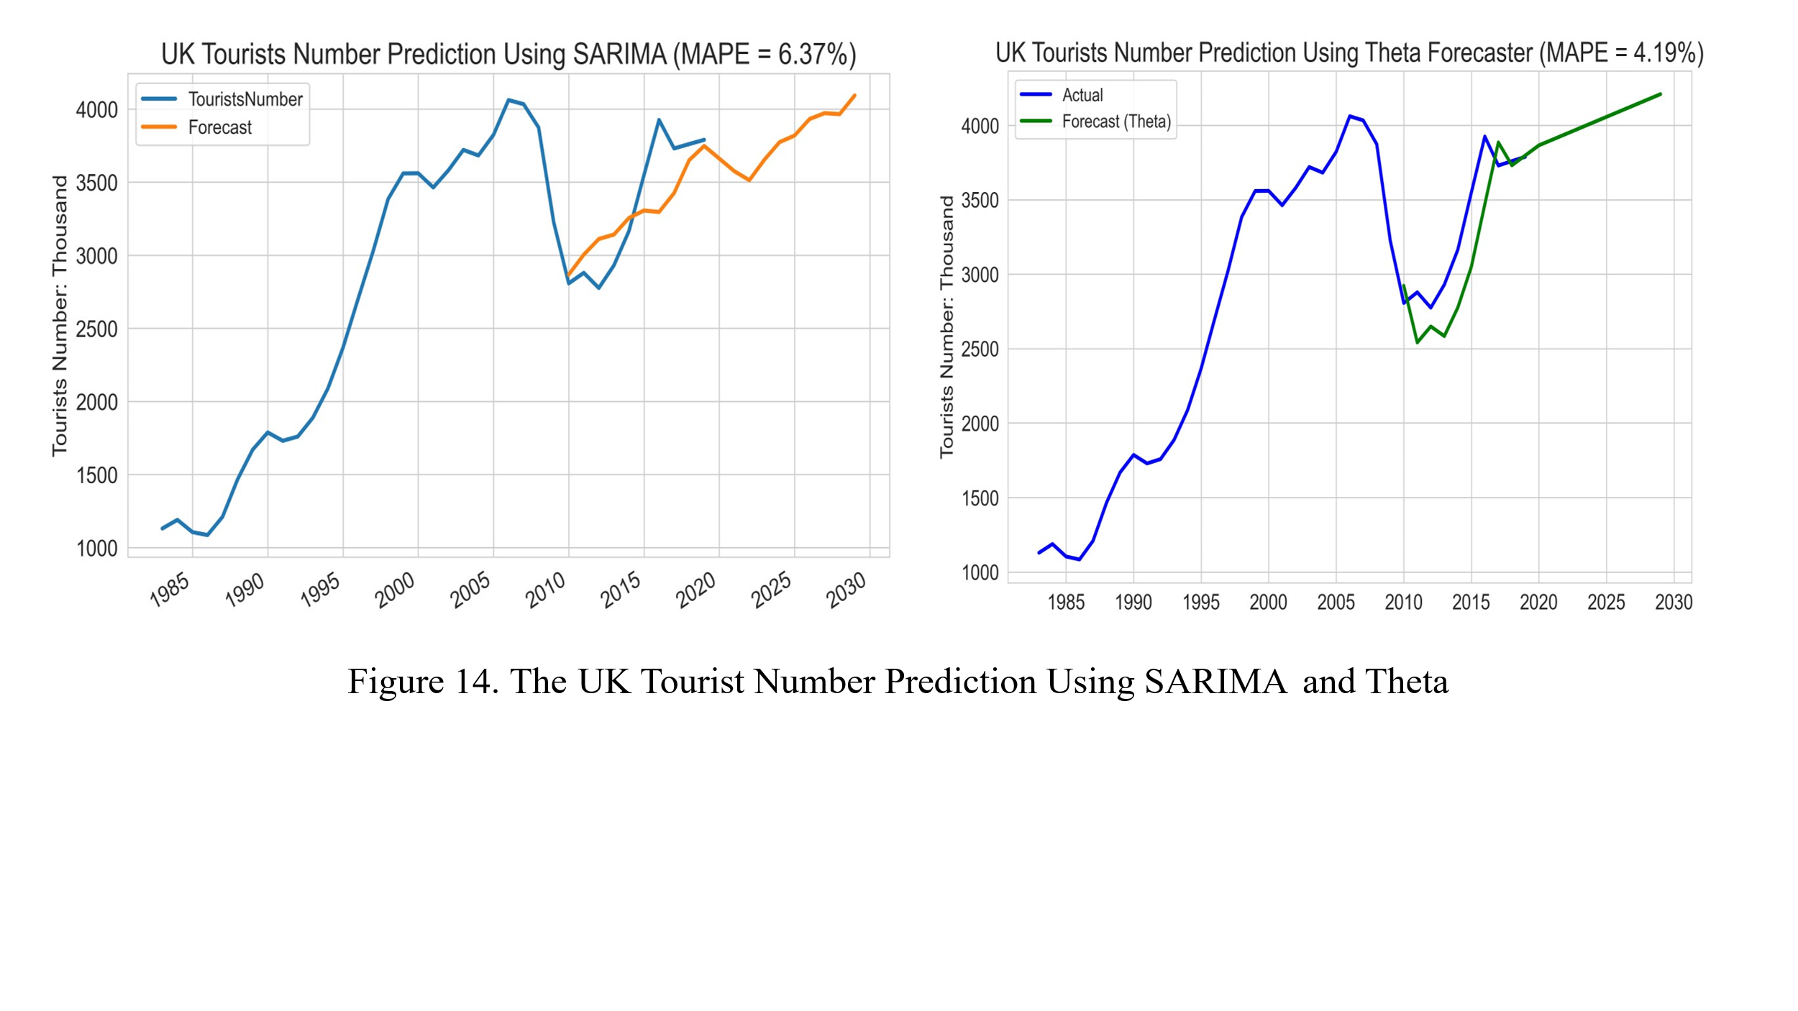

## ***7.2 The US and Canada: Total Tourist Expenditure, Per Tourist Per Night Expenditure, and Tourist Numbers***

By using the same methods, the ACF and PACF plots for forecasting the US and Canada total tourist expenditure, per tourist per night expenditure, and tourist numbers can be seen in the following Figure 15.

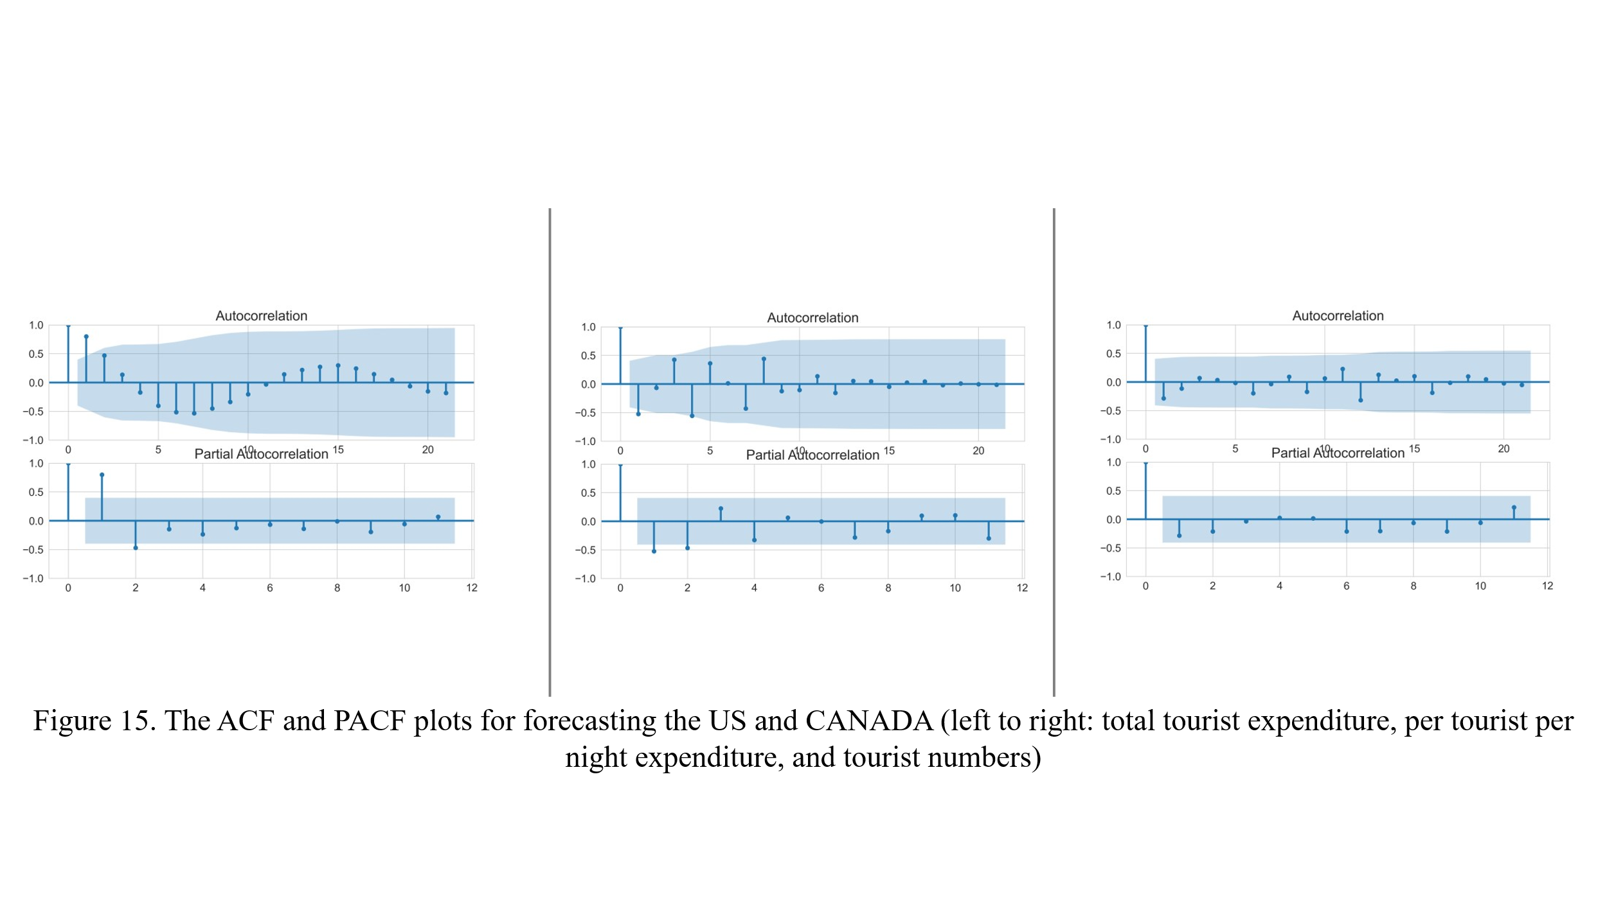

Forecasting for the US and CANADA total tourist expenditure can be seen in the following plots (Figure 16).

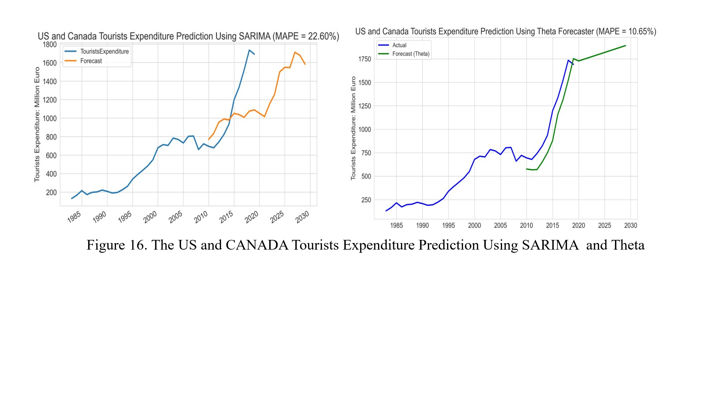

Forecasting for the US and CANADA per tourist per night tourist expenditure can be seen in the following plots (Figure 17).

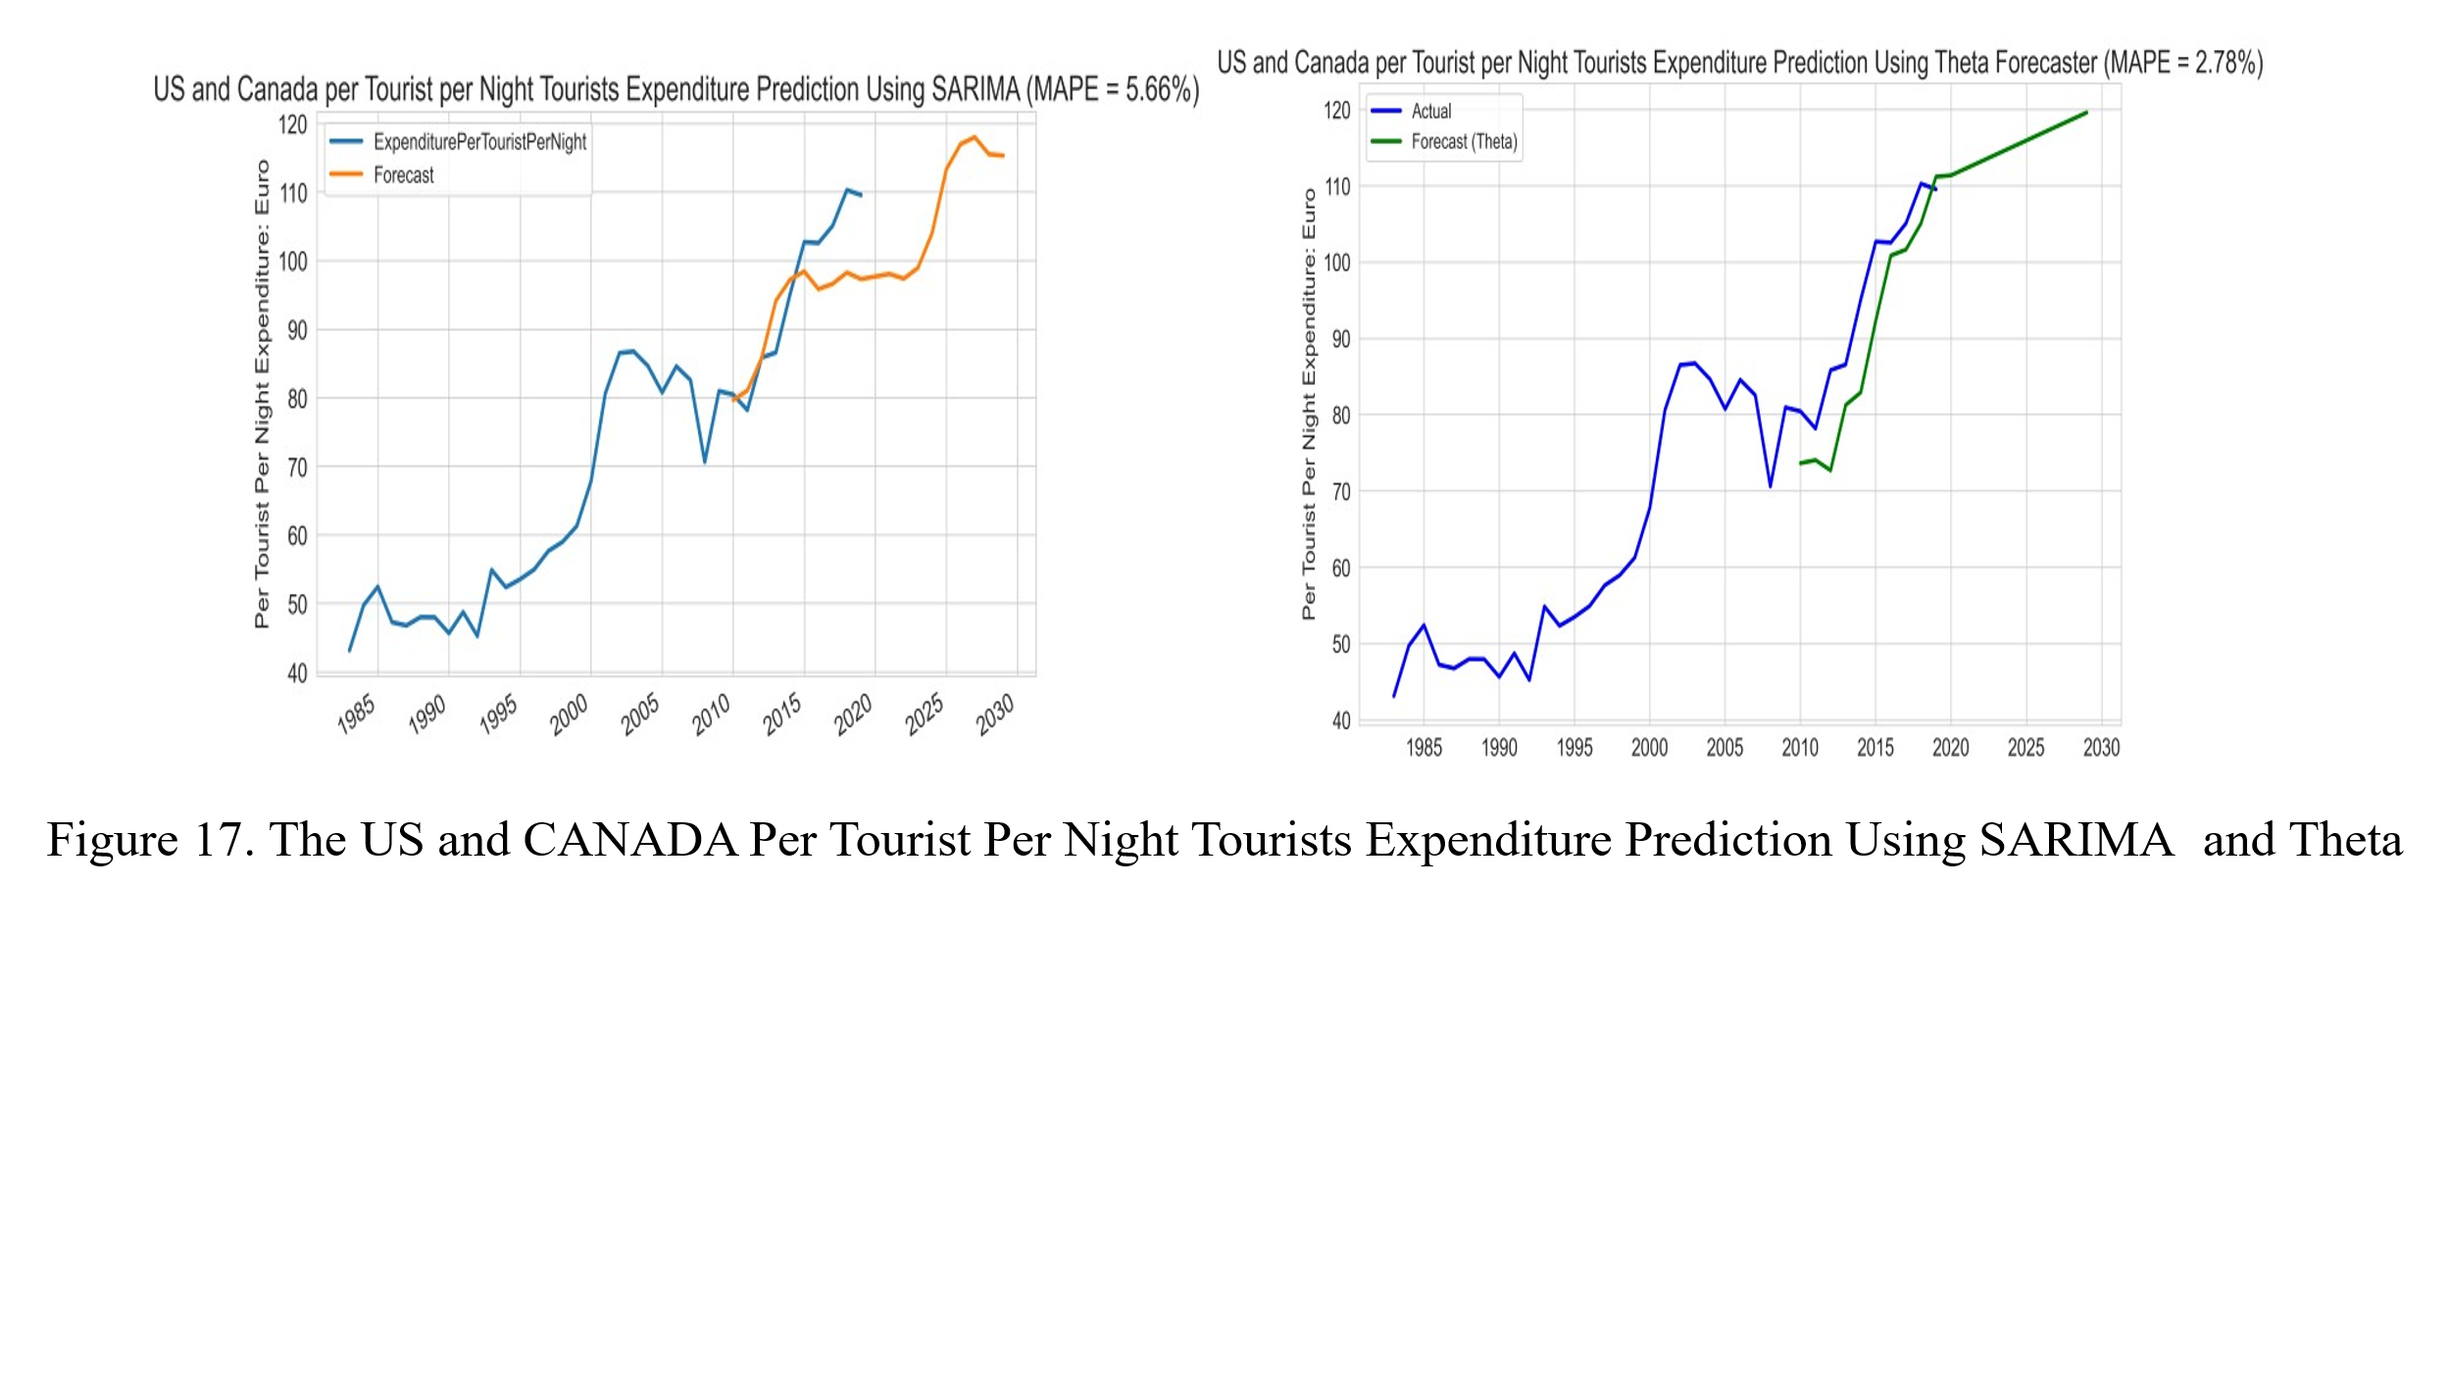

Forecasting for the US and Canadian tourist numbers can be seen in the following plots (Figure 18).

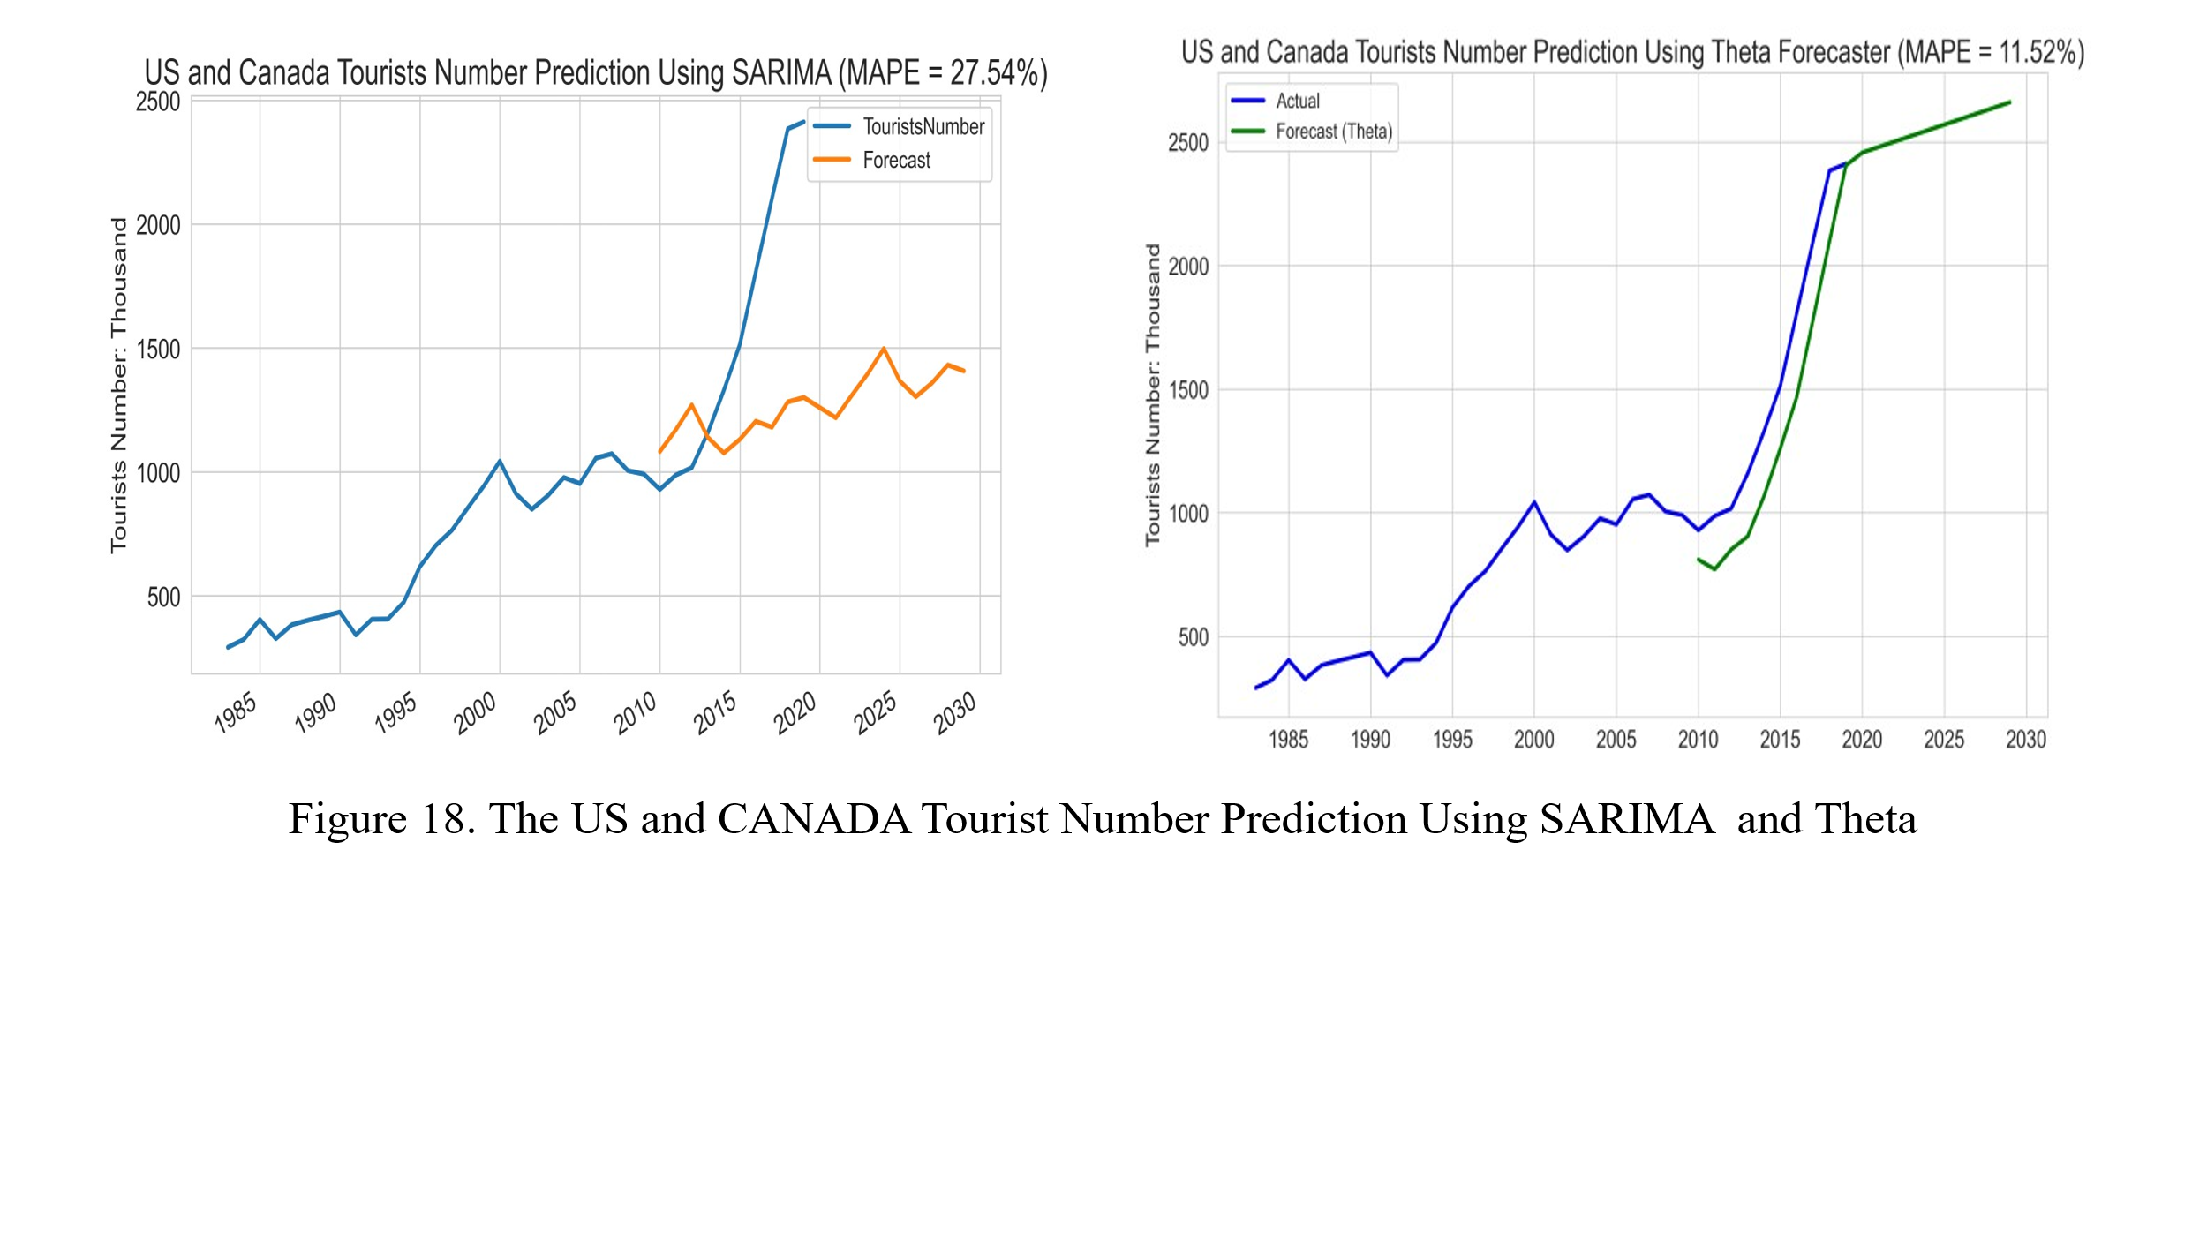

## ***7.3 Model Evaluation and Comparison***

In this assignment, the Mean Absolute Percentage Error (MAPE) is used to evaluate and compare the forecasting model’s performance. MAPE measures the average absolute percentage difference between forecasted and actual values; lower values reflect better model performance.

The MAPE comparisons can be seen in the following Figure 19.

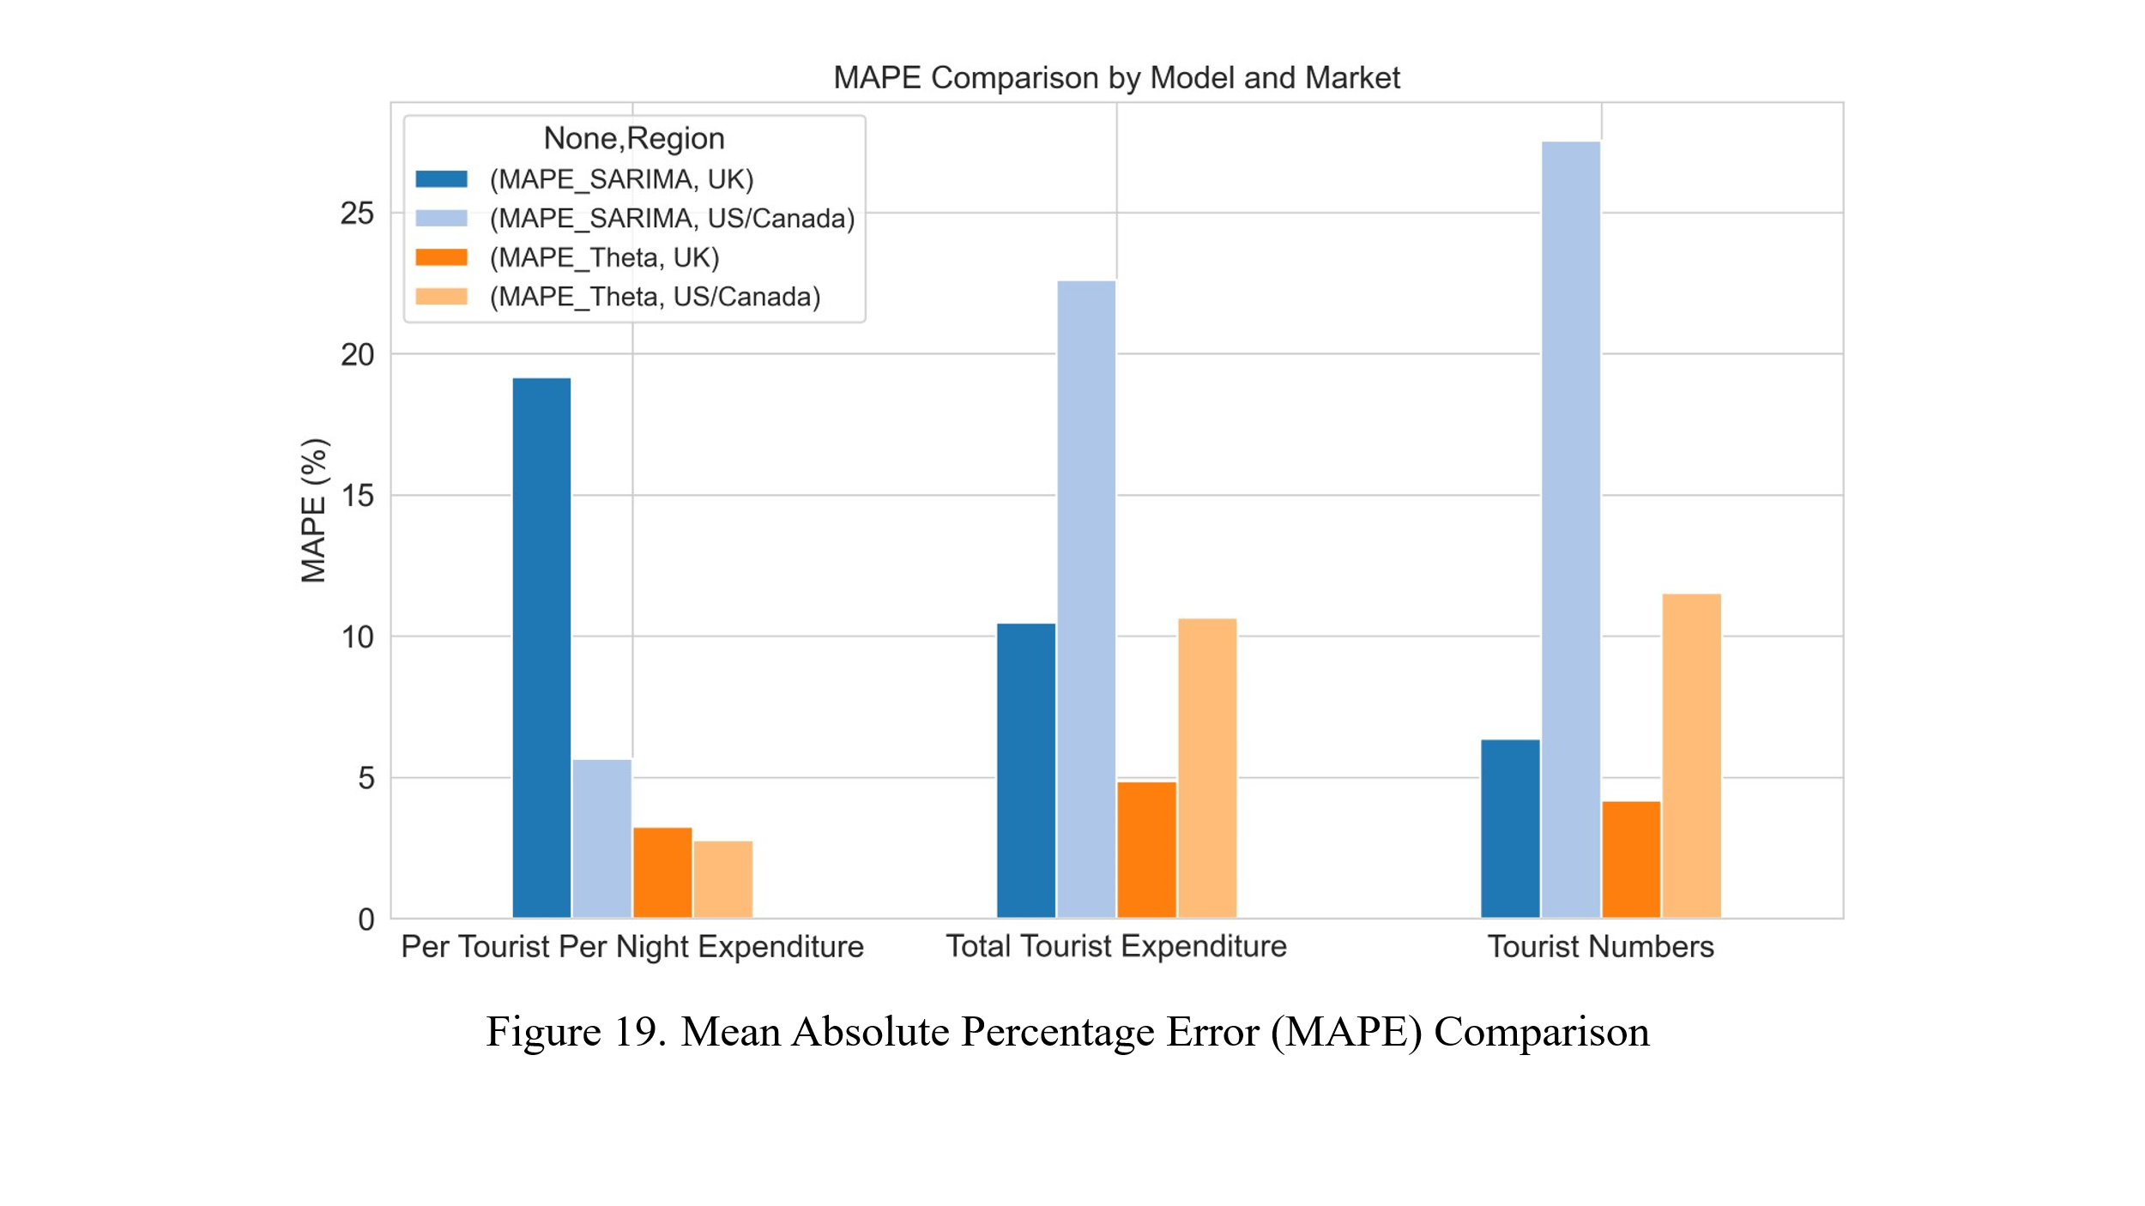

Figure 19 shows that the Theta model consistently outperforms the SARIMA model across all tourism indicators examined. For example, in forecasting the UK per tourist per night expenditure, Theta achieved an MAPE of 3.26% compared to SARIMA’s 19.18%. Similarly, for US/Canada tourist numbers, Theta recorded 11.52% versus SARIMA’s 27.54%. Thus, the Theta model can be the preferred choice for forecasting the Irish inbound tourism demand.

# 8. Challenges Encountered and Solutions

The main challenges of this assignment can be described from two perspectives: data size and its contents.

The yearly dataset of 2009 – 2019 Irish inbound tourism is not enough for performing the time series algorithm. So, an additional dataset (1983 – 2008) was obtained from the Central Statistics Office of Ireland (Central Statistics Office, 2020ab), combined with the previous dataset, and produced a bigger dataset that covers the period from 1983 to 2019. This new dataset is still not enough to perform time series analysis, since they are yearly data. Thus, by using the Python technique, 10 years of future yearly dates from 2020 to 2029 are produced. This allows us to perform the time series analysis.

In terms of data content, both datasets include features such as overseas tourists’ numbers to Ireland, their average stay nights and tourism spending. However, the more historical dataset (1983 – 2008) only contains individual country data for the UK, the USA and Canada. So, the combined dataset is produced by focusing on these countries. This is feasible because these countries are the main contributors to Irish inbound tourism, as previously discussed.

# 9. Findings, Recommendations, and Conclusion

Using time series forecasting models ARIMA, SARIMA and Theta, this assignment analysed and forecasted inbound tourism to Ireland. The forecast focused on the two most significant source markets: the United Kingdom and the United States/Canada. Key forecasting indicators include total tourist expenditure, per tourist per night expenditure, and tourist numbers. Forecast model performance is evaluated using Mean Absolute Percentage Error (MAPE), where lower values indicate higher accuracy.

Findings show that the UK remains the highest-volume source market, i.e. the highest number of tourists comes from the UK. The US/Canada represents a higher value in terms of per tourist per night expenditure. The predictive analysis indicates that US/Canadian tourists are characterised by higher per-visitor expenditure and more gradual growth.

The Theta model consistently outperforms SARIMA across all indicators and both markets. This model should be considered for use in the Irish inbound tourism prediction.

The US/Canada tourists represent a higher per-visitor expenditure, and the forecasting indicates that this trend is a gradual growth.

Based on these insights, the following recommendations are proposed regarding the Irish inbound tourism business and development policy:

* The Theta model should be considered for use in the Irish inbound tourism prediction.
* The Irish Tourism Authority should conduct dedicated surveys on inbound tourist behaviour, including transportation choices, travel frequency, destination preferences, age profiles, booking channels, accommodation preferences, overall travel experience, and so on. These enriched datasets, when integrated with existing statistics, would enable to conduct of more effective forecasting.
* Data collection, statistical reporting, and research efforts, for example, in terms of monthly data, should focus particularly on key markets identified in the forecasting analysis: Great Britain, the United States & Canada, Germany, and France.
* In line with Ireland’s tourism strategic priority of maximising economic value per visitor rather than increasing tourist volume, targeted tourism development policies should be formulated. This includes shifting focus from mass tourism to value-driven tourism products and services tailored to the expectations and spending patterns of visitors from the key countries. This would help the government to implement its tourism sustainable development strategy, i.e., equally consider the environmental, economic, and social pillars of sustainability.

In summary, there is a shift from British tourists’ dominance towards North American tourists, i.e., the United States & Canada, in both spending and visitor numbers. However, it is important to consider all potential forecasting biases which might be caused by inadequate data in terms of size and content previously mentioned. The Irish inbound tourism demand prediction models should be continuously improved in future projects.

# References

Arunraj, N.S., Ahrens, D. and Fernandes, M., 2016. Application of the SARIMAX model to forecast daily sales in the food retail industry. *International Journal of Operations Research and Information Systems (IJORIS)*, *7*(2), pp.1-21.

Central Statistics Office, 2020a. TMA09 - Overseas Trips (incl. Expenditure) to Ireland - data.gov.ie (Date updated 2020-09-15). Available at: <https://data.gov.ie/dataset/tma09-overseas-trips-incl-expenditure-to-ireland> (Accessed: 20 October 2024).

Central Statistics Office, 2020b. TMA06 - Overseas Visits to Ireland (Date updated 2020-05-14). Available at: <https://data.cso.ie/> (Accessed: 13 April 2025).

Cheer, J.M. and Lew, A.A., 2017. Understanding tourism resilience: Adapting to social, political, and economic change. In Tourism, resilience and sustainability (pp. 3-17). Routledge.

Government of Ireland, 2024. *Tourism Policy Framework 2025–2030.* Available at: <https://www.gov.ie/pdf/?file=https://assets.gov.ie/311416/2b0fbb57-62df-4b6c-b90f-4af38fff290e.pdf#page=null> (Accessed: 24 November 2024).

Gunter, U. and Önder, I., 2015. ‘Forecasting international city tourism demand for Paris: Accuracy of uni- and multivariate models employing monthly data’, Tourism Management, 46, pp. 123–135. Available at: https://doi.org/10.1016/j.tourman.2014.06.017.

Irish Tourism Industry Confederation, 2024. *‘VISION 2030 – An Irish Tourism Strategy for Growth’, Irish Tourism Industry Confederation - ITIC.* Available at: <https://www.itic.ie/vision-2030/> (Accessed: 24 November 2024).

Isik, M., 2025. ‘Airline Passenger Forecasting’. Available at: https://kaggle.com/code/mehmetisik/airline-passenger-forecasting (Accessed: 19 January 2025).

McKinney, W., 2012. Python for Data Analysis: Data Wrangling with Pandas, NumPy, and IPython. O’Reilly Media, Inc.

Perktold, . et al., 2024. The Theta Model. ‘statsmodels/statsmodels: Release 0.14.2’. Zenodo. Available at: <https://doi.org/10.5281/ZENODO.593847>.

Shearer, C., 2000. The CRISP-DM model: the new blueprint for data mining. *Journal of Data Warehousing*, *5*(4), pp.13-22.

Song, H. and Li, G., 2008. ‘Tourism demand modelling and forecasting—A review of recent research’, Tourism Management, 29(2), pp. 203–220. Available at: <https://doi.org/10.1016/j.tourman.2007.07.016>.

Song, H., Qiu, R.T.R. and Park, J., 2019. ‘A review of research on tourism demand forecasting: Launching the Annals of Tourism Research Curated Collection on tourism demand forecasting’, Annals of Tourism Research, 75, pp. 338–362. Available at: <https://doi.org/10.1016/j.annals.2018.12.001>.

Weiss, N., 2016. Introductory Statistics, MyLab Revision, Global Edition. 10th edition. Boston; Columbus; Indianapolis, New York: Pearson.

[**GitHub Link**](https://github.com/P-Idikut/Data-Analytics-for-Business)